Reading extract and questions:
Year 2
The Kite
Set A/B

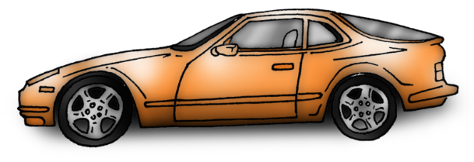
Tyler had been looking forward to his birthday for weeks. Now he was down to his last present. It was long, thin and light. No way could it be the remote-controlled car he had longed for.
“And this is from Great Uncle Gordon,” said his mum, trying to sound more cheerful than she was feeling. She had done her best, but she could tell Tyler was disappointed.
He tore off the paper. It was a kite. “Great,” muttered Tyler and threw it to one side. Then he stomped off to his room. Mum quietly slipped the kite out of sight.
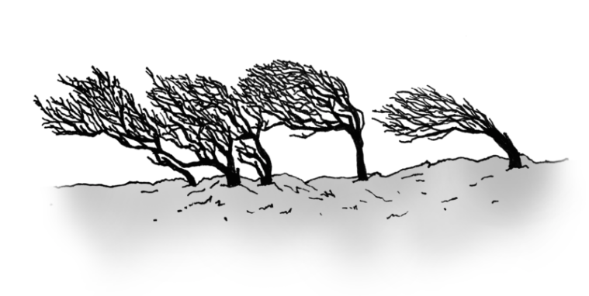
A couple of months later, the family were in the local park. It was a bright, breezy day. Tyler was running around, having a great time scrambling over the climbing frames and chasing his friends around.
Now and again, he jogged over to take a sip from his bottle of water. “You know that kite you got for your birthday?” said Mum. “Mind if we give it a go?”
“Go for it,” replied Tyler before dashing off again.
Dad watched while Mum and Dylan, Tyler’s younger sister, set up the kite. Mum checked which way the wind was going, then held on to the ends of the twin strings while Dylan held the kite above her head.
Mum walked backwards about thirty paces. Dylan stretched as high as she could. There was a strong gust. Mum tugged on the strings and the kite jerked out of Dylan’s hands.
“Hooray!” cried Dylan as the kite climbed into the sky with its colourful tail swirling beneath it.
“Come and have a go,” said Mum.
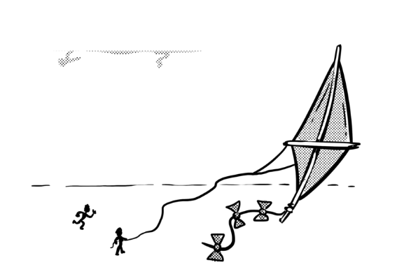
Dylan squealed and gasped as it ducked and danced on the breeze. Suddenly, Tyler was by her side, asking to have a go. She handed him the string holders. Mum gave him a few tips on what to do.
Soon, he was laughing and cheering. He couldn’t take his eyes off it. Before long, he was able to control each spiral and swoop. It was only when his arms started to ache that he let the others have another go. “Happy birthday, love,” grinned Mum.

Questions for
The Kite
Set A
Vocabulary

1. … he had longed for… In this sentence, longed for means … Tick one.

reached out for really wanted

belonged to waited for

2. Look at the paragraph beginning ‘Now and again …’ Find and copy one word that means ran slowly.

_________________________________________________________________

3. … his arms started to ache … In this sentence, ache means … Tick one.

hurt stretch

wobble wave

Identify key aspects
4. Who was Tyler’s last present from?

_________________________________________________________________

5. What was Tyler’s younger sister called?

_________________________________________________________________

6. How far back did Mum walk when she was holding the kite strings?

_________________________________________________________________

Inference
7. Why was Tyler disappointed when he got the kite?

_________________________________________________________________

8. How did Dylan feel when the kite climbed into the sky? Tick one.

very tired very cross

very pleased very worried

Sequence
9. Number the events from 1 to 4 to show the order in which they happened.
Tyler played with his friends.
Tyler had a go with the kite.
Tyler unwrapped his last present.
Mum and Dylan got the kite to fly.

Predict
10. How do you think Tyler would reply to Mum saying, “Happy Birthday”?

_______________________________________________________________________________

Questions for
The Kite
Set B

Vocabulary

1. … Then he stomped off … In this sentence, stomped means … Tick one.

tip-toed crept

walked angrily bounced

2. … the local park … In this sentence, local means … Tick one.

cheap adventure

play nearest

3. Look at the paragraph beginning ‘Mum walked backwards ...’ Find and copy a word that means burst of wind.

_________________________________________________________________

Identify key aspects
4. What had Tyler really wanted for his birthday?

_________________________________________________________________

5. How did Tyler feel when he first saw the kite?

_________________________________________________________________

6. What was swirling beneath the kite?

_________________________________________________________________

Inference
7. How was Tyler feeling when they were in the park? Tick one.

disappointed tired

bored happy

8. Mum thought Tyler didn’t know how to fly a kite. How do we know this?

_________________________________________________________________

Sequence
9. Number the events from 1 to 4 to show the order in which they happened.

Dylan held the kite above her head.
Mum hid the kite.
Mum showed Tyler how to fly the kite.
The family went to the park.

Predict
10. What do you think Tyler will say next time Mum suggests going to the park?

_________________________________________________________________

Answers for The Kite

Set A:

Vocabulary:
1. really wanted
2. jogged
3. hurt
Retrieval:
4. Great Uncle Gordon
5. Dylan
6. (about) thirty paces
Inference:
7. He had been hoping for a remote-controlled car.
8. very pleased
Sequence:
9.
Tyler played with his friends. | 2
Tyler had a go with the kite. | 4
Tyler unwrapped his last present. | 1
Mum and Dylan got the kite to fly. | 3

Predict:
10. Accept any answers that suggest Tyler recognises he was wrong about the kite, e.g. “Thanks Mum. That kite was a great present after all.”

Commissioned by The PiXL Club Ltd. January 2020
This resource is strictly for the use of member schools for as long as they remain members of The PiXL Club. It may not be copied, sold nor transferred to a third party or used by the school after membership ceases. Until such time it may be freely used within the member school.
All opinions and contributions are those of the authors. The contents of this resource are not connected with nor endorsed by any other company, organisation or institution.
PiXL Club Ltd endeavour to trace and contact copyright owners. If there are any inadvertent omissions or errors in the acknowledgements or usage, this is unintended and PiXL will remedy these on written notification.

© Copyright The PiXL Club Limited, 2020
Answers for The Kite
Set B:

Vocabulary:
1. walked angrily
2. nearest
3. gust
Retrieval:
4. a remote-controlled car
5. disappointed
6. a colourful tail
Inference:
7. happy
8. She gave him a few tips on what to do.
Sequence:
9.
Dylan held the kite above her head. | 3
Mum hid the kite. | 1
Mum showed Tyler how to fly the kite. | 4
The family went to the park. | 2

Predict:
10. Can we/Shall we take the kite?

Commissioned by The PiXL Club Ltd. January 2020
This resource is strictly for the use of member schools for as long as they remain members of The PiXL Club. It may not be copied, sold nor transferred to a third party or used by the school after membership ceases. Until such time it may be freely used within the member school.
All opinions and contributions are those of the authors. The contents of this resource are not connected with nor endorsed by any other company, organisation or institution.
PiXL Club Ltd endeavour to trace and contact copyright owners. If there are any inadvertent omissions or errors in the acknowledgements or usage, this is unintended and PiXL will remedy these on written notification.

© Copyright The PiXL Club Limited, 2020

