Detail | Information
Academic year that this summary covers | 2025 - 26
Date this summary was published | 10/25
Date this summary will be reviewed | 9/26
Name of the school music lead | Sara-Jayne Tempest
Name of school leadership team member with responsibility for music (if different) | Louise Watkins
Name of local music hub | Norfolk and Suffolk Music Hub
Name of other music education organisation(s) (if partnership in place)

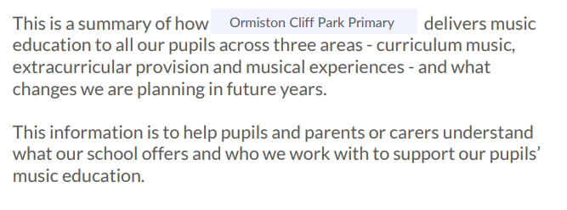


Curriculum music is music taught in lesson time to all pupils.
Year group | Time dedicated to curriculum music teaching each week | Time dedicated to curriculum music teaching each week  Instrumental scheme
EYFS | 4 half terms: 20 minutes
Year 1 | 3 half terms: 1 hour
Year 2 | 3 half terms: 1 hour
Year 3 | 3 half terms: 1 hour | 1 term: 1 hour
Year 4 | 3 half terms: 1 hour | 1 term: 1 hour
Year 5 | 3 half terms: 1 hour
Year 6 | 3 half terms: 1 hour

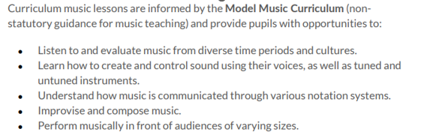
An instrumental scheme is also delivered by our Year 3 and 4 teachers and gives pupils an opportunity to learn the glockenspiel for a prolonged period, allowing them to develop technical proficiency on a single instrument.

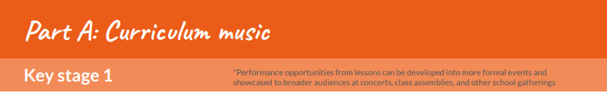
Year 1 | Lesson opportunities to sing and play instruments | Lesson performance opportunities
Autumn 1:  Keeping the pulse | Singing a sentence, keeping a steady pulse. Keeping the pulse of the music and playing sound patterns using body percussion and untuned instruments. | Performing to the class in pairs to show pulse and rhythm.
Spring 1:  Sound patterns | Practising different sound patterns using instruments. | Using instruments to tell the story of the ‘Three little pigs’ to the class.
Summer 1:  Pitch | Using tuned percussion instruments to play a simple tune. | Performing superhero theme tunes as a group to the class.
Summer 2:  Musical symbols | Using tuned percussion and clapping to play different symbols to represent the sea. | Performing under the sea sounds as a group to the class

Year 2 | Lesson opportunities to sing and play instruments | Lesson performance opportunities
Autumn 1:  Call and Response  (Animals) | Using body percussion and voices to share call and response patterns | Performing different call and response patterns in groups to the class.
Spring 1:  Instruments (Musical storytelling) | Working in groups to use instruments and create music that matches a storyboard | Working as a group to perform music to match the story of 'Jack and the Beanstalk.’
Summer 1:  Structure | Using instruments to perform different sound patterns. | Performing sound patterns as a group using instruments
Summer 2:  Pitch | Using tuned percussion instruments, children read from a score and perform a song. | Performing ‘Once a man fell in a well’ as a class using voices and instruments.

Year 3 | Lesson opportunities to sing and play instruments | Lesson performance opportunities
Autumn 1:  Ballads | Singing in time and in tune with a song and incorporating actions. | Performing their own ballad in groups and incorporating actions.
Spring 1:  Developing singing technique | Practising different warm ups and learning a song using a variety of different pitches. | Performing a song about the Vikings with associated actions.
Summer 1:  Pentatonic melodies and composition | Experimenting with scat singing and syncopated rhythms. | Performing a jazz version of a nursery rhyme
Summer 2:  Traditional instruments and improvisation | Practising a traditional Indian song | Performing the song ‘Anile Vaa’.

Year 4 | Lesson opportunities to sing and play instruments | Lesson performance opportunities
Autumn 1:  Body and tuned percussion | Experimenting with combining body percussion and tuned percussion instruments to create rhythms of the rainforest. | Performing group rainforest compositions to the class.
Spring 1:  Changes in pitch, tempo and dynamics | Creating and practising vocal and percussive ostinatos. | Performing different ostinatos to represent a river in groups
Summer 1:  South America | Practising a piece of music with four layers. | Performing a samba piece as a class
Summer 2:  Romans | Learning to sing a song with a variety of pitches. | Performing ‘The Road building song’ as a class.

Year 5 | Lesson opportunities to sing and play instruments | Lesson performance opportunities
Autumn 1:  Composition notation (Ancient Egypt) | Creating and practising a piece of music using graphic notation. | Performing a composition to represent a pharaoh as a group.
Spring 1:  Blues | Practising the 12 bar blues chords and accompanying bass line on instruments. | Performing the 12 bar blues and improvisation in pairs.
Summer 1:  South and West Africa | Singing unaccompanied and incorporating movement | Performing ‘Shosholoza’ as a class.
Summer 2:  Composition to represent the festival of colour | Creating a vocal piece to represent a picture. | Performing a vocal class composition.

Year 6 | Lesson opportunities to sing and play instruments | Lesson performance opportunities
Autumn 1:  Dynamics, pitch and tempo (Fingal’s Cave) | Creating a group composition. | Performing compositions as a group based on the piece ‘Fingal’s cave.’
Spring 1:  Theme and Variation (Pop art) | Composing a multi-layered piece of music with voices, bodies and Instruments. | Performing compositions in groups to create a class performance.
Summer 1:  Baroque | Playing instruments using graphic and staff notation (and their own notation). | Performing ‘Funky fugue’ as a class
Summer 2:  Composing and performing a Leavers’ Song | Creating and practising a leavers’ song. | Performing leavers’ song in assembly.


Year group | Assembly time dedicated to music learning each week | Extra curricular club opportunities | Music tuition
EYFS: Reception | All year children have access to musical instruments. They also sing songs, nursery rhymes or clap rhythms daily.
Year 1 | 25 minutes | Choir – Summer term
Year 2 | 25 minutes | Recorders Choir
Year 3 | 25 minutes | Recorders Choir
Year 4 | 25 minutes | Recorders Choir
Year 5 | 25 minutes | Recorders Choir
Year 6 | 25 minutes | Recorders Choir

£ a pound sign means there is a cost to parents/careers for this extra-curricular activity.


 | Autumn | Spring | Summer
EYFS | School Christmas concert Snow White pantomime |  | Watch the schools Summer Showcase Watch High school students perform Be part of Music week
Year 1 | School Christmas concert Snow White pantomime |  | Perform in and watch the schools Summer Showcase Watch High school students perform Be part of Music week
Year 2 | School Christmas concert Local Sounds4Christmas concert Singing at the local hospital for cancer patients Snow White pantomime |  | Perform in and watch the schools Summer Showcase Watch High school students perform Be part of Music week
Year 3 | School Christmas concert Local Festival of carols concert Singing at local care home Snow White pantomime |  | Perform in and watch the schools Summer Showcase Watch High school students perform Be part of Music week
Year 4 | School Christmas concert Local Festival of carols concert Singing at local care home Snow White pantomime |  | Perform in and watch the schools Summer Showcase Watch High school students perform Be part of Music week
Year 5 | School Christmas concert Local Festival of carols concert Singing at local care home Snow White pantomime |  | Perform in and watch the schools Summer Showcase Watch High school students perform Be part of Music week
Year 6 | School Christmas concert Local Festival of carols concert Singing at local care home Snow White pantomime |  | Perform in and watch the schools Summer Showcase Watch High school students perform Be part of Music week

Ormiston Cliff Park Primary Academy are committed to continually enhancing musical offerings to pupils. Below are the improvements we plan to implement in the coming years. We welcome your suggestions and encourage you to contact the school if you have any ideas on how we can further improve our musical opportunities.
Improvement | Who will benefit | Is the change to: A: curriculum music B: extra-curricular music C: musical experiences? | When will the change be introduced
Music making club | Reception + Year 1 | B: extra-curricular music | January 2026
Opportunity to experience a live orchestra | All children | C: musical experiences | When available

